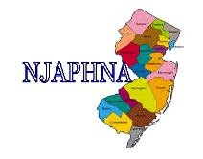New Jersey Association of Public Health Nurse Administrators, Inc

Membership Application 2017

Name

Home Address
(Including City and State)

Home Phone Cell phone

Employer_

Address (include City) (County)

Phone_ _Fax:_

Email_

Degrees Held
_Certifications

Member of NJSNA? Yes_ No Other Organizations?

DUES: Active Member $75 Associate Member $35. (retired) ** check payable to: NJAPHNA

Status: Active_ Associate_ Amount Enclosed Will you serve on a committee? Choose below.

Continuing Education/Best Practices _Membership Emergency Preparedness

Communicable Disease
_Chronic Disease _Nominations Website

Practice Standards Maternal-Child Health
_Bylaws

Send application and payment to: Jane Scarfo 31 Ivanhoe Lane, Clifton NJ 07013

